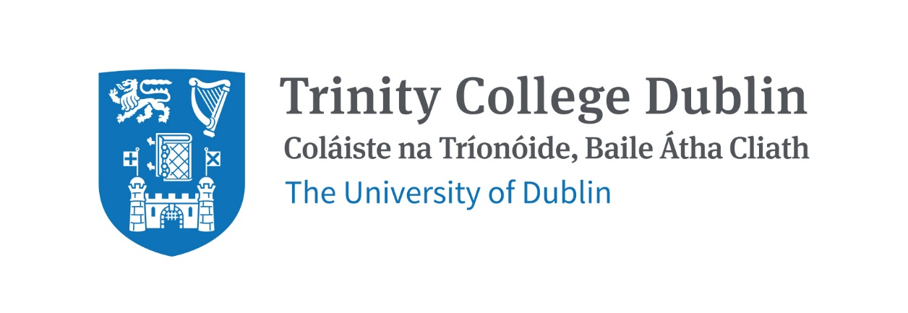

Trinity Business School

Business Analytics

2026/27

MODULE CODE: BUU33803

MODULE NAME: Business Analytics

ECTS: This course carries 5 ECTS credits

Lecturer: Eoin Lane (Adjunct Lecturer)

Phone: +353 83 027 0372

E-mail: eolane@tcd.ie
Office Hours: By appointment (room to confirm)

Pre-Requisite:
No prior programming experience is required. Students should be comfortable working with numbers and willing to learn to use software for analysis. The module places more weight on interpreting results and applying them to business problems than on mathematical derivation.

The module has run for two years and has been well received, including by international and Erasmus students. It has been updated for 2026/27 to use AI tools (Claude) and Google Colab for analysis, alongside Python. SPSS and R are no longer used.

MODULE DESCRIPTION
Businesses rely on insights produced through careful analysis of data. This module covers the main analytical techniques used to support business decisions, and how to interpret and act on their results. Students learn to define a business question, choose an appropriate technique, run the analysis using software, and assess whether the output can be relied upon before drawing conclusions.

The techniques covered are linear regression, logistic regression and classification, clustering, and association rules and recommendation systems. For each one, students learn how the method works, how to read its output, and how to apply it to a business case. The software used is Excel, Python (in Google Colab), and AI tools (Claude) for writing and explaining code. For software access, see https://www.tcd.ie/itservices/.

LEARNING AND TEACHING APPROACH
The module is taught through weekly in-person sessions. A typical session introduces a technique and then has students apply it to a real dataset in class, using AI tools to help with the coding. Students are asked to form a view about what an analysis will show before they run it, so that they engage with the output rather than simply reporting it. Business cases, worked examples and short supplementary materials support each topic. No previous programming knowledge is assumed.
Attendance is recorded at each session (see the Attendance Policy below). In line with School policy, recordings of lectures are not provided. Session slides, worked solutions and the notebooks used in class are made available on Blackboard for revision, and a recommended companion text (Naked Statistics) is suggested for students who have not studied statistics before. Arrangements for tutorial support in 2026/27 will be confirmed by the UG team.

MODULE-LEVEL LEARNING OUTCOMES
Explain how each technique covered in the module works and the kind of business question it can answer.
- Build a model using appropriate software and interpret its main outputs, including coefficients, statistical significance and measures of fit.
- Use AI tools effectively and critically when carrying out an analysis, and identify where their output is unreliable or wrong.
- Apply the techniques to business cases and turn the results into a clear, evidence-based recommendation.
- Take account of the ethical, fairness and sustainability implications of data-driven decisions, including social and environmental as well as economic considerations.

RELATION TO DEGREE
This is an analytics elective for Junior Sophister students on the BESS and Global and Sustainable Business programmes, and is also open to visiting students. It develops practical skills in data analysis and in the use of analytical software and AI tools that are relevant across business roles and to later modules.

WORKLOAD
Content | Indicative Number of Hours
Lecturing hours | 22
Preparation for lectures | 32
Individual assignment | 26
Group assignment | 45
Reading of assigned materials and active reflection on lecture and course content and linkage to personal experiences | 45
Total | 170

TEXTBOOKS AND REQUIRED RESOURCES

Required core course textbook:
- TB1 – “Data Science for Business: What You Need to Know about Data Mining and Data-Analytic Thinking” by Foster Provost and Tom Fawcett, Publisher(s): O'Reilly Media, Inc., ISBN: 9781449361327
- TB2 – “Introduction to Machine Learning with Python: A Guide for Data Scientists” by Andreas C. Mueller and Sarah Guido, Publisher(s): O'Reilly Media, Inc., ISBN: 9781449369415.
- TB3 – “Complete Business Statistics”, by Amir Aczel and Jayavel Sounderpandian, Publisher(s): McGraw-Hill Higher Education, ISBN: 9780071284936
- TB4 – “Mining of massive datasets”, by Jure Leskovec, Anand Rajaraman and Jeffrey Ullman, Publisher(s): Cambridge University Press, ISBN: 9781139924801, Online: http://www.mmds.org/

General Supplemental Readings:
- Wheelan, C. (2013). Naked Statistics: Stripping the Dread from the Data. W.W. Norton. A non-technical introduction to statistics, recommended for students without a statistics background.
- McKinney, W. (2022). Python for Data Analysis. 3rd ed. O'Reilly. An optional reference for students who want more depth in Python.
- Selected short readings on the use of AI tools in analytics and on data ethics, fairness and sustainability will be assigned during the term.
- HBR Case articles and research papers will be assigned in the course outline and classroom lectures.

Student preparation for the module

Attendance Policy
Students are expected to attend the in-person sessions, and a minimum of two-thirds attendance is expected. Attendance is recorded at each session (using Vevox) and may be taken into account in borderline grade decisions. Recordings of lectures are not provided. Students who expect to miss more than one-third of the sessions should contact the lecturer with a valid reason. Medical absences should be reported as soon as possible.

Preparation
Students should complete any assigned reading before each session and allow sufficient time outside class, in line with the module workload, to revise the material and work on the assignments. Access to Google Colab and to the AI tools used in the module should be set up before the second session.

COURSE COMMUNICATION

All email about the module must be sent from the student's official TCD email address; email from other addresses will not be answered. Blackboard is used for all module materials, organised by session.

ASSESSMENT
The module is assessed by two components of equal weight (50% each); an overall pass is required. The assessment is designed so that the learning outcomes are demonstrated by the student rather than produced by an AI tool alone, with weight given to interpretation, judgement, and work done in person. Use of AI tools is permitted, and students are assessed in part on how well they use and evaluate them. Submission is through Blackboard.

Group Assignment (50%) - group project (bank marketing data), due at the end of the Michaelmas semester, 2026
Students work in groups on a project using a real bank-marketing dataset, applying techniques from the module. As in previous years, additional credit is available to groups that form on their own and include a mix of students (for example, domestic, Erasmus and international).
Deliverables:
- A written report (35%), of about 1,500 words, presenting the analysis and a business recommendation.
- An in-class presentation (10%) on the final day of teaching, which may include a short question-and-answer session.
A short reflection (5%) on the student's use of AI tools during the project, with the supporting record. Further details will be given in the first session.

Individual Assignment (50%) - in-class test, held after the first five sessions (around reading week)
An in-class assessment on Blackboard covering linear and logistic regression. It is open-book, and the use of software and the internet, including AI tools, is permitted. The assessment is designed to test understanding and judgement rather than recall, for example by asking students to interpret an analysis, choose and justify a method, and make a recommendation. The exact arrangements will be confirmed with the UG office.
Deliverables:
- In-class test on Blackboard.

RE-ASSESSMENT
Students who do not pass overall will be permitted to take a supplemental assessment, in line with School policy.
MODULE SCHEDULE

Term
Session | Date & venue | Topic & core reading
1 |  | Introduction to business analytics; working with software and AI tools (Advertising, Bike Sharing). TB1, Ch. 1-2.
2 |  | Linear regression: building and interpreting models, with a short review of statistics (Advertising, Armand's Pizza). TB1 Ch. 4; TB3 Ch. 1-4; Naked Statistics.
3 |  | Linear regression: diagnostics, validation and model checking (Bike Sharing, Car Prices). TB1 Ch. 4.
4 |  | Classification and logistic regression; the Challenger case; introduction to data ethics (Challenger, German Credit). TB1 Ch. 4; TB2 Ch. 2.
5 |  | Logistic regression: evaluation and fairness (Bank Marketing, German Credit). TB1 Ch. 4; TB2 Ch. 2.
6 |  | Individual assessment (in-class test).
7 |  | Clustering: distance measures and grouping (Iris, Wine, Bike Sharing). TB1 Ch. 6; TB2 Ch. 3.
8 |  | Clustering: segmentation and customer personas (Bank Marketing). TB2 Ch. 3.
9 |  | Association rules and recommendation systems (Amazon / market-basket data). TB4 Ch. 6, 9.
10 |  | Review and integration; support for the group project (various datasets).
11 |  | Group project presentations (Bank Marketing).
Notes |  | Foundational statistics (random variables, distributions, correlation and significance) is reviewed in the early sessions and supported by Naked Statistics and TB3 (Ch. 1-4). The module is taught in a single two-hour session each week; the day and venue follow the timetable. Teaching begins in the week of 14 September 2026, with reading week in the week of 26 October and the final teaching week beginning 30 November 2026.

Biographical Note:
Eoin Lane is Founder and CEO of Noval Consulting, an Adjunct Professor at Trinity Business School, and a Research Fellow at the ADAPT Centre, where he co-leads the joint Dublin City Council/ADAPT Generative AI Lab. He works at the intersection of AI strategy, public-sector transformation, and responsible AI governance, helping organisations build the right AI capabilities rather than simply deploy the latest tools. His current work spans AI programme delivery at the National Transport Authority, smart-city AI infrastructure with Dublin City Council and Dublin Fire Brigade, board-level AI governance education grounded in the EU AI Act, and edtech AI platform development through the Diotima project with Learnovate. He previously spent twelve years at IBM as Chief Architect for Intelligent Energy and Water, and went on to build and lead BNY Mellon's Global AI Hub in Dublin. He holds over 70 patents granted and pending, and a PhD in Chemistry from University College Cork.

