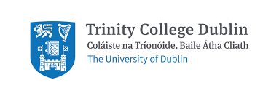
THE SECOND ANNUAL
BARBARA WRIGHT
MEMORIAL LECTURE IN FRENCH LITERATURE

WEDNESDAY 27 APRIL 2022 at 1 p.m.
TRINITY LONG ROOM HUB
Professor Peter Read (Professor of Modern French Literature and Visual Arts, University of Kent)
will speak on
Visual Poetry in Scotland and France: Ian Hamilton Finlay, Poussin and Apollinaire
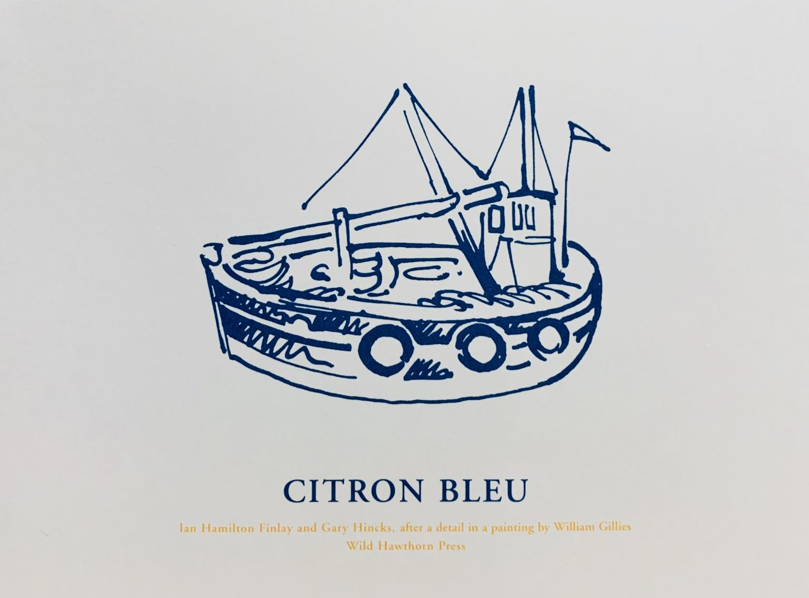

ALL WELCOME

The French Department of Trinity College Dublin is delighted to announce the second Annual Barbara Wright Memorial Lecture in French Literature. The series has been established to honour the memory of Professor Barbara Wright (1935-2019) and will be inspired by her broad scholarly interests and achievements. A renowned specialist primarily in nineteenth-century literature and textual and visual studies, Professor Wright’s distinction was recognised by the French Government: she was made a Chevalier de l’ordre national du mérite in 1975 and a Chevalier de la légion d’honneur in 2019. A renowned expert on painter, writer and art critic Eugène Fromentin, Professor Wright’s interests extended beyond literature to art and music. The Barbara Wright Prize, awarded annually to the Senior Sophister in the French Department who obtains the highest result (and not less than a First) in French literature, is an inspiring and enduring testimony to her scholarly rigour. For further details see https://www.irishtimes.com/life-and-style/people/barbara-wright-obituary-acclaimed-scholar-who-broke-trinity-glass-ceiling-1.4142965
The lecture will be delivered by Professor Peter Read, Professor of Modern French Literature and Visual Arts at the University of Kent. His lecture is a fitting tribute to Professor Wright’s work on textual and visual studies.

Résumé: Visual Poetry in Scotland and France: Ian Hamilton Finlay, Poussin and Apollinaire.
The poet and artist Ian Hamilton Finlay (1925-2006) began writing short stories while working as a shepherd and a labourer in Perthshire and on the Orcadian island of Rousay. Subsequently fixing his art at the crossroads of visibility and legibility, Finlay went on to spend forty years transforming Stonypath, a seven-acre farm steading in the Pentland Hills, south of Edinburgh, into an extraordinary garden, which he rechristened Little Sparta. Across this redesigned territory, which he opened to intrepid visitors and collectors, Finlay installed 270 pieces of his word-based art, sculpted in stone, wood and other materials. Refusing to be labelled an “avant-gardener”, Finlay declared that his main aspiration was “neo-classical rearmament”. Often challenging, sometimes controversial, his work incorporates his informed interest in Mediterranean antiquity, European modernism, Scotland’s seafaring traditions, and military iconography. This illustrated lecture will serve as an introduction to his whole creative trajectory, but will focus on how his appreciation of the French Revolution and his dialogue with French artists and writers from the 17th to the 20th centuries contributed to the development of Little Sparta and to Finlay’s prolific output of works on paper and card, meticulously published by his own Wild Hawthorn Press.
About the speaker:
Peter Read is Emeritus Professor of Modern French Literature and Visual Arts at the University of Kent, Canterbury, UK and was previously Professor of French at the University of St Andrews in Scotland, where he lived and worked for over twenty years. His books include Picasso and Apollinaire: The Persistence of Memory (University of California Press, 2008) and Apollinaire: lettres, calligrammes, manuscrits (Paris, BnF/Textuel, 2016). He has published numerous essays on the work of 20th-century European artists and poets, on cubism and on Picasso’s poetry, and has contributed chapters to exhibition catalogues for museums in Britain, France, Spain, the USA and other countries. He was on the Advisory Committee of Apollinaire: le regard du poète, an exhibition at the musée de l’Orangerie in Paris in 2016. He has also edited volumes of critical essays and correspondence, is on the editorial board of Forum for Modern Language Studies and Comparative Studies in Modernism and he is a regular contributor to TLS.
Organiser:
Dr Sarah Alyn Stacey, FTCD, Académie de Savoie, Chevalier de l’ordre national du mérite
French Department
Trinity College Dublin
E-mail: salynsta@tcd.ie
RSVP to Sarah Alyn Stacey by 25 April 2022

This lecture is made possible through the generous support of the School of Languages, Literatures and Cultural Studies, Trinity College Dublin, the Trinity Long Room Hub, and the Trinity College Dublin Trust.
