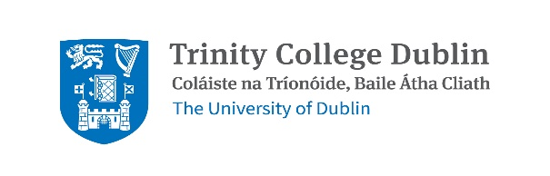

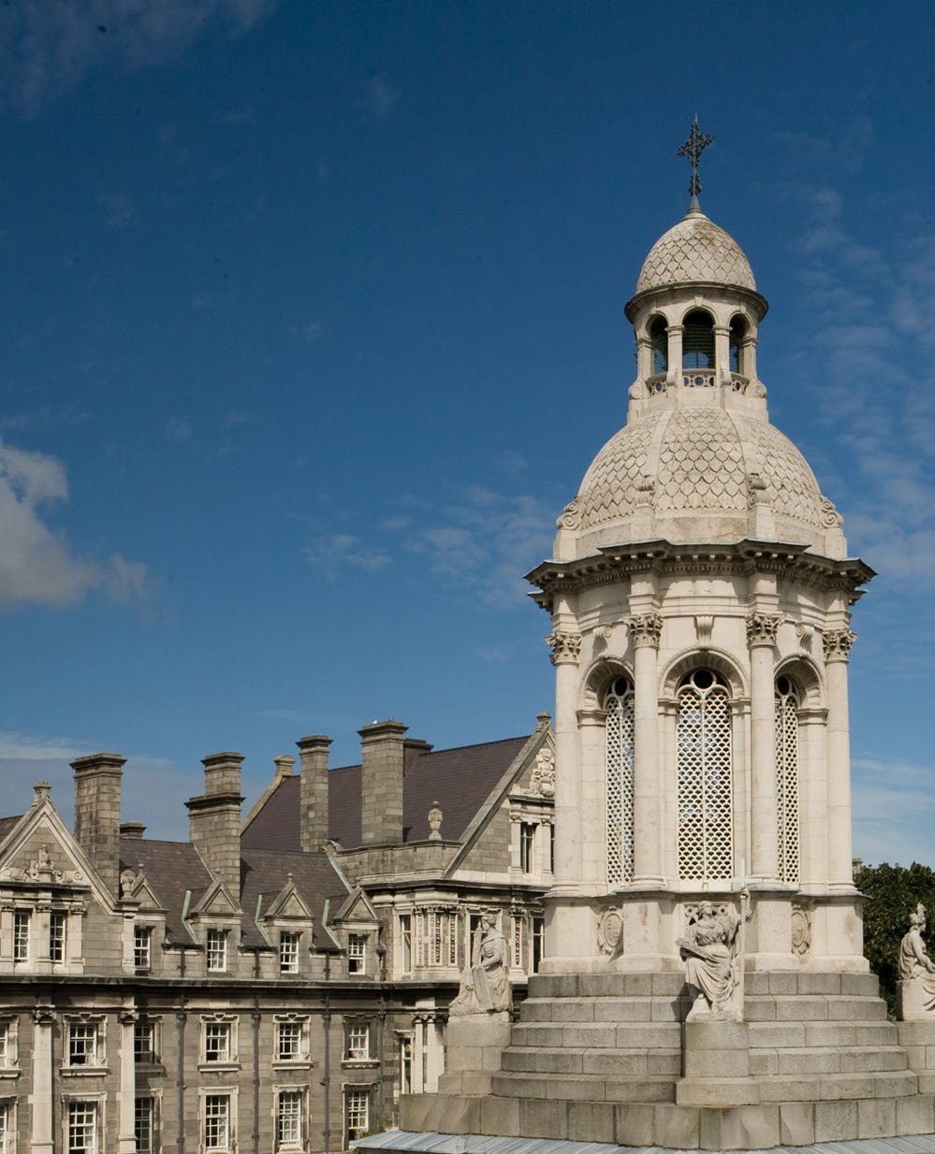

School of Social Sciences & Philosophy
Department of Sociology

PhD in Sociology Handbook

2025/2026

Table of Contents

1. General College Information 5
1.1 Student Services & Support 5
1.2 Postgraduate Advisory Service (PAS) 5
1.3 Support Provision for Students with Disabilities 6
1.4 Co-Curricular Activities 7
1.5 Emergency Procedure 7
1.6 Data Protection 7
1.7 Health & Safety Statements 8
1.8 University Regulations 8
2. General Course Information 9
2.1 Introduction 9
Welcome from Programme Director/s 9
Welcome from the Programme Administrator 10
2.2 Programme Governance 11
2.3 Contact Details 11
2.4 Key Locations 11
2.5 Key Dates 12
2.6 Timetable 14
3. Scholarships & Prizes 15
3.1 Research Allowance Application 15
4. Academic Policies 16
4.1 Academic Integrity & Referencing 16
4.1.1 Academic Integrity 16
4.1.2 Academic Misconduct in the Context of Group Work 17
4.1.3 Avoiding Academic Misconduct 17
4.1.4 Procedures regarding Dignity & Respect Matters 18
4.2 Research Ethics 18
5. Teaching & Learning 19
5.1 Programme Structure 19
5.2 Programme Structure & Workload 19
Thesis Committee 20
Training Components 22
Confirmation Report 23
Confirmation Interview 24
5.3 Attendance Requirements 24
5.4 Progression Regulations 25
5.4.1 Appeals 26
5.5 Careers Information & Events 26

A note on this Handbook
In the event of any conflict or inconsistency between the General Regulations published in the University Calendar and information contained in programme or local handbooks, the provisions of the General Regulation in the Calendar will prevail.
Alternative formats of the Handbooks can be made available on request.

1. General College Information

1.1 Student Services & Support
The Programme Administrator sociology@tcd.ie is your first port of call for all general queries. College also provides a range of administrative, academic and wellbeing supports and services to help smooth your route through college. You can find further information at the links below:
- Careers Advisory Service | www.tcd.ie/careers
- Graduate Studies Office | www.tcd.ie/graduatestudies
- Mature Student Office | www.tcd.ie/maturestudents
- Student Services Website | www.tcd.ie/studentservices
- Trinity Disability Service | www.tcd.ie/disability
- Student Learning Development | https://student-learning.tcd.ie/

1.2 Postgraduate Advisory Service (PAS)
What?
The Postgraduate Advisory Service (PAS) is a free and confidential service available to all registered postgraduate students in Trinity College. PAS offers a comprehensive range of academic, pastoral and professional supports including one-to-one appointments, workshops and trainings, and emergency financial assistance.
Why?
PAS exists to ensure that all postgraduates students have a dedicated, specialist service independent of the School-system to whom they can turn for support and advice during their time at Trinity. Common concerns students present to PAS include stress; financial worries; queries about regulations or services available at Trinity; supervisor-relationship concerns; academic progression issues; academic appeals.
Who?
The Postgraduate Advisory Service is led by the Postgraduate Student Support Officers who provide frontline support for all Postgraduate students in Trinity. These Support Officers will act as your first point of contact and a source of support and guidance; they can also put you in touch with or recommend other services, depending on your needs.
How?
For an appointment, please e-mail postgrad.support@tcd.ie.
For further information, please visit our website, check out the regular PAS newsletter sent to all postgraduates via email, or follow PAS on Instagram (@TCDPGAdvisory).

1.3 Support Provision for Students with Disabilities
Trinity has adopted a Reasonable Accommodation Policy that outlines how supports are implemented in Trinity. Students seeking reasonable accommodation whilst studying in Trinity must apply for reasonable accommodations with the Disability Service in their student portal my.tcd.ie.
Based on appropriate evidence of a disability and information obtained from the student on the impact of their disability and their academic course requirements, the Disability Staff member will identify supports designed to meet the student’s disability support needs. Following the Needs Assessment, the student’s Disability Officer prepares an Individual Learning Educational Needs Summary (LENS) detailing the Reasonable Accommodations to be implemented. The information outlined in the LENS is communicated to the relevant School via the student record in SITS.
Further information on Postgraduate Student Supports here.
Examination accommodation and deadlines:
Students should make requests as early as possible in the academic year. To ensure the Assessment, Progression and Graduation Team can set your accommodations for examination purposes the following deadlines are applied:
- Semester 1 assessments: the last Friday of October annually.
- Semester 2 assessments: the last Friday of February annually.
Student responsibilities for departmental assessments/course tests:
Students are required to initiate contact with the School/Department and request reasonable accommodations as per their LENS report, or email received following their needs assessment for particular assessments for School/ Department administered assessment. Students are advised to make contact at least two weeks prior to the assessment date to enable adjustments to be implemented.
Please note: no reasonable accommodation can be provided outside the procedures outlined in the Trinity Reasonable Accommodation Policy. For further information please visit: https://www.tcd.ie/disability/current/how-reasonable-accommodations-work-in-trinity/

1.4 Co-Curricular Activities
- TCD Sports Clubs | https://www.tcd.ie/sport/student-sport/sport-clubs/
Trinity has 50 sports clubs in a range of disciplines, from Basketball to Archery.
- TCD Societies | trinitysocieties.ie
Trinity offers over 100 societies across the University. From arts, culture, politics and debating to gaming, advocacy and music, you're sure to find your niche.
- Student Union | www.tcdsu.org
The Trinity College Students Union is a union for students, by students. It represents the student body at College level.

1.5 Emergency Procedure
In the event of an emergency, dial Security Services on extension 1999. Security Services provide a 24-hour service to the college community, 365 days a year. They are the liaison to the Fire, Garda and Ambulance services and all staff and students are advised to always telephone extension 1999 (+353 1 896 1999) in case of an emergency. Should you require any emergency or rescue services on campus, you must contact Security Services. This includes chemical spills, personal injury or first aid assistance. It is recommended that all students save at least one emergency contact in their phone under ICE (In Case of Emergency).

1.6 Data Protection
Please note that due to data protection requirements, staff in the School of Social Sciences and Philosophy cannot discuss individual students with parents/guardians or other family members. As the University considers students, even if they are not yet 18, to have the maturity to give consent for the use of their data, in normal circumstances, the University will not disclose personal data to the parents, guardians or other representatives of a student without the student’s consent.
The University’s preference is to receive written consent by way of email from the student where possible. Without such consent the University will not release any details regarding students including details of their registration, attendance, results, fee payments etc.
Trinity College Dublin uses personal data relating to students for a variety of purposes and we are careful to comply with our obligations under data protection laws.
Further information on how we obtain, use, and disclose student data can be viewed on the Trinity website: www.tcd.ie/dataprotection

1.7 Health & Safety Statements
The College Safety Statement can be viewed on the Trinity website:
https://www.tcd.ie/students/orientation/shw/

1.8 University Regulations
Please reference the links below for College regulations, policies and procedures:
- Academic Policies
https://www.tcd.ie/about/policies/academic-policies/
- Student Complaints Procedure
https://www.tcd.ie/about/policies/university-policies/complaints-procedure/
- Dignity and Respect Policy
https://www.tcd.ie/hr/dignity-and-respect/policies/

2. General Course Information

2.1 Introduction

Welcome from Programme Director/s
Dear Students,
You have decided to join an excellent PhD programme which is designed to produce rigorously trained, widely-read and well-rounded sociologists who take their place at the forefront of the profession.
Doing a PhD is hard work, but it is also a unique and fantastic experience that can contribute to your intellectual and personal development. Our PhD programme offers an exceptional opportunity to elaborate your research ideas and to develop and deepen critical academic skills such as asking good research questions, analytical thinking, collecting and analysing data, presenting your academic achievements to broader audiences, and writing as well as publishing academic papers in peer-reviewed journals. As an active member of the department, you will also gather fundamental competences in teaching.
On behalf of the whole department of Sociology, the School of Social Sciences and Philosophy and the entire College, we would like to welcome you to this journey warmly! We want to let you know that you are not alone in your Ph.D. Professional supervision and guidance and a plethora of college-wide services and training opportunities are there for you.
That said, we wish you a wonderful start and all the best for the years to come!
Professor Daniel Faas, PhD Director Sociology & Professor Elaine Moriarty (Head of Department)

Welcome from the Programme Administrator
Dear Students,
My name is Fiona McIntyre and I am the programme administrator for all students registered on the PhD Sociology programme. If you have any administrative queries, you can email me at sociology@tcd.ie or drop into the office (Room 3.03, College Green, Mondays-Fridays from 8.00am– 4.00pm.
Please ensure you regularly check your Trinity email account as I will use this for all administrative correspondence. In the meantime, enjoy the start of term and please do make contact if you have any queries.
Best wishes
Fiona McIntyre

2.2 Programme Governance
The Sociology PhD programme is governed by the Department PhD Management Committee which is a sub-committee of the School of Social Sciences and Philosophy Executive and Post-graduate Teaching and Learning Committees. Membership of the Sociology PhD Programme Management Committee includes the Head of Department (Chair), PhD Programme Director, Administrative Officer (Secretary) and a student representative.
Head of the School of Social Sciences & Philosophy
Professor Paul O’Grady | Tel. +353 1 896 1522 | E-mail: pogrady@tcd.ie

Head of Department
Professor Elaine Moriarty | Tel. +353 1 896 1296| E-mail: emoriar@tcd.ie
School Director of Teaching & Learning (Post-Graduate)
Professor Selim Gulesci | E-mail: gulescis@tdc.ie
Course Director/s
Professor Daniel Faas | Tel. +353 1 896 3443 | E-mail: faasd@tcd.ie
School Manager
Ms Olive Donnelly | Tel. +353 1 896 2499 | E-mail: olive.donnelly@tcd.ie

Programme Administrator
Ms Fiona Mc Intyre | Tel. +353 1 896 2701 | E-mail: sociology@tcd.ie

2.3 Contact Details

2.4 Key Locations
Department
The Sociology Department is located on the 4th and 5th floors of 1 College Green building, just off the West end of the main campus.
(Note: 1 – 5 College Green is a combined building, the main entrance is at 3 College Green. Turn left on exiting the main list or staircase in order to reach 1 College Green. If taking the lift to the fifth floor of 1 College Green, press four; if taking the lift to the fourth floor of 1 College Green, press three).
Maps of campus are available at https://www.tcd.ie/Maps/map.php
Blackboard
Blackboard is the College online learning environment, where lecturers will give access to material like lecture notes and discussion forums. The use of Blackboard varies from module to module and individual lecturers will speak to you about the requirements for their module. In order to access a module on Blackboard you should be registered to the module by your Programme Administrator. Blackboard can be accessed via tcd.blackboard.com.
Email
All official email correspondence will be sent to TCD email addresses only. You should check your email on a regular basis. When emailing the Administration, students should always include their TCD Student ID Number.
Student Portal
https://my.tcd.ie allows students to view their own central student record containing all relevant information related to the course for which you are registered. To access the system, you will need your College username and network password.
If your personal student information is incorrect, you should contact Academic Registry (via email, academic.registry@tcd.ie) stating your full name and student ID number. If your timetable module list is incorrect then you should notify the Programme Administrator.
Academic Registry
Academic Registry (“AR”) manages course registration and fees. Their website can be accessed here: https://www.tcd.ie/academicregistry/. The Academic Registry offices are located in the Watts Building, on the east side of the main campus.

2.5 Key Dates
Michaelmas Term

8—12 September 2025 Postgraduate Orientation Week, Call opens for IRC ‘Government of Ireland Postgraduate Scholarship Programme’.
15 September 2025 Teaching term starts.
TBC October 2025 Research Ireland: deadline https://research.ie/funding/goipg/.
27—31 October 2025 Study Week (No teaching).
1 December 2025 Teaching term ends.
Hilary Term
January 2026 Exam grading; Teaching Assistants (TAs) should plan to be in Dublin.
12 January 2026 Teaching Assistants and lecturers inform Sociology office of MT module marks.
19 January 2026 Teaching term starts.
2—6 March 2026 Study Week (No teaching).
10 April 2026 Last teaching day.
13 April 2026 PhD Research Day - mandatory

2.6 Timetable
The updated course timetable will be available online shortly before the start of the Michaelmas term. Personal timetables will be available to students through https://my.tcd.ie.
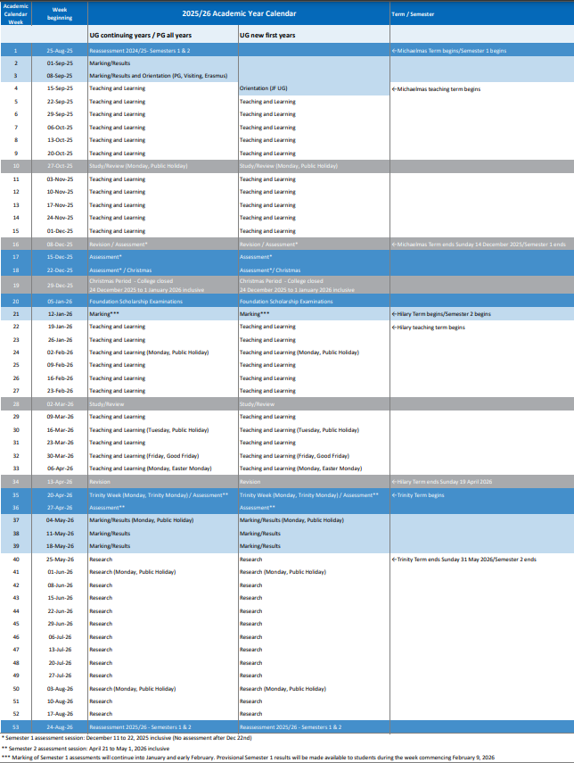
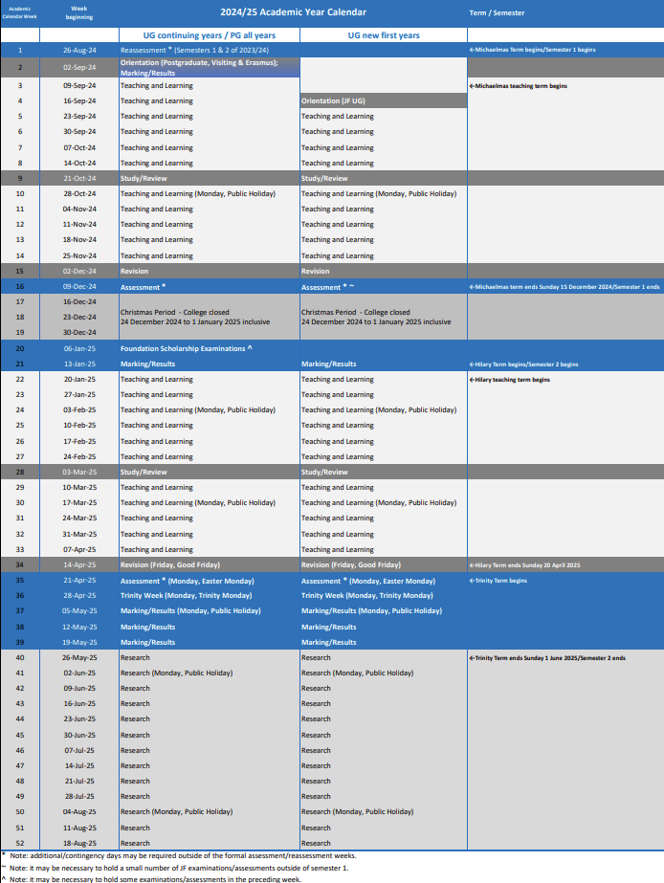
The Academic Year Structure is available here.

3. Scholarships & Prizes

3.1 Research Allowance Application
A research allowance for conference travel is available for all PhD students who are currently on the Department Award. The allowance covers the cost of travel, accommodation and conference registration only. You will have to cover the cost initially before reimbursement can be made. The Programme Administrator (see contacts above) will provide you with a form for seeking approval for allowances. All applications must be approved in writing by the Head of Department before you make any purchases.

4. Academic Policies

4.1 Academic Integrity & Referencing

4.1.1 Academic Integrity
It is clearly understood that all members of the academic community use and build on the work and ideas of others. However, it is essential that we do so with integrity, in an open and explicit manner, and with due acknowledgement. Any action or attempted action that undermines academic integrity and may result in an unfair academic advantage or disadvantage for any member of the academic community or wider society may be considered as academic misconduct. Examples of academic misconduct include, but are not limited to:
- Plagiarism - presenting work / ideas taken from other sources without proper acknowledgement. Submitting work as one’s own for assessment or examination, which has been done in whole or in part by someone else or submitting work which has been created by using artificial intelligence tools, where this has not been expressly permitted.
- Self-plagiarism - recycling or borrowing content from the author’s own previous work without citation and submitting it either for an assignment or an examination.
- Collusion - undisclosed collaboration of two or more people on an assignment or task, or examination, which is supposed to be completed individually.
- Falsification/fabrication.
- Exam cheating - action or behaviour that violates examination rules in an attempt to give one learner an unfair advantage over another.
- Fraud/impersonation - actions that are intended to deceive for unfair advantage by violating academic regulations. Using intentional deception to gain academic credit.
- Contract cheating - form of academic misconduct in which a person uses an undeclared and/or unauthorised third party to assist them to produce work for academic credit or progression, whether or not payment or other favour is involved. Contract cheating is any behaviour whereby a learner arranges to have another person or entity (‘the provider’) complete (in whole or in part) any assessment (e.g., exam, test, quiz, assignment, paper, project, problems) for the learner. If the provider is also a student, both students are in violation.
Further examples of the above available at www.tcd.ie/teaching-learning/academic-integrity.

Artificial Intelligence
Aligned with the College Statement on Artificial Intelligence and Generative AI in Teaching, Learning, Assessment & Research (2024), the use of GenAI is permitted unless otherwise stated. Where the output of GenAI is used in a document or work output, this usage should be acknowledged and appropriate cited, as per Library guidelines on acknowledging and reference GenAI.
Please check the relevant syllabus/module description on Blackboard for details of any restrictions on specific modules.

4.1.2 Academic Misconduct in the Context of Group Work
Students should normally submit assessments and/or examinations done in co-operation with other students only when the cooperation is done with the full knowledge and permission of the lecturer concerned. Without this permission, submitting assessments and/or examinations which are the product of collaboration with other students may be considered to be academic misconduct.
When work is submitted as the result of a group project, it is the responsibility of all students in the group to ensure, so far as is possible, that no work submitted by the group is plagiarised, or that any other academic misconduct has taken place. In order to avoid academic misconduct in the context of collaboration and group work, it is particularly important to ensure that each student appropriately attributes work that is not their own. Should a module coordinator suspect academic misconduct in a group assignment, the procedure in cases of suspected academic misconduct must be followed for each student.

4.1.3 Avoiding Academic Misconduct
Students should ensure the integrity of their work by seeking advice from their module coordinator or supervisor on avoiding academic misconduct. All schools and departments must include, in their handbooks or other literature given to students, guidelines on the appropriate methodology for the kind of work that students will be expected to undertake. In addition, a general set of guidelines for students on avoiding academic misconduct is available at libguides.tcd.ie/academic-integrity.
Each coversheet that is attached to submitted work should contain the following completed declaration:
"I have read, and I understand the academic integrity provisions in the General Regulations of the University Calendar for the current year. I have also completed the Online Tutorial on avoiding plagiarism ‘Ready Steady Write’.
Please refer to your relevant School/ Department for the format of essay submission coversheets.
For further information including details of the procedure to be followed in case of suspected plagiarism, please refer to Section 1, ‘Academic Integrity’ (pages 30 & 31) of the Graduate Studies Academic Calendar:
www.tcd.ie/calendar/graduate-studies-higher- degrees/complete-part-III.pdf.

4.1.4 Procedures regarding Dignity & Respect Matters
The School of Social Sciences and Philosophy is committed to fostering a learning environment that upholds principles of equality, diversity, and inclusion. We strive to ensure that all students and staff can pursue their academic and professional goals without fear of discrimination, harassment, bullying, or any form of mistreatment.
Recognizing the adverse impact harassment can have on individuals' performance, morale, confidence, health, and learning, the School seeks to create a culture where such behavior is unequivocally condemned. Our goal is to encourage an atmosphere in which individuals can address harassment concerns without fear of ridicule or retaliation.
Trinity Dignity and Respect Policy sets out the College’s key principles and procedures for addressing matters related to negative treatment, including discrimination, bullying, and any form of harassment. TCD Sexual Misconduct Policy establishes the principles, approach and procedures on the subject of sexual harassment or sexual assault and outlines the resources and support available to both students and staff when facing issues related to sexual harassment.
Should any student encounter issues related to dignity and respect, as outlined above, we strongly urge them to immediately reach out for support from the designated contact person, who will provide guidance and support in accordance with the Dignity and Respect Policy:
- Course Director Professor Daniel Faas |faasd@tcd.ie
- School Director of Teaching and Learning (Post-Graduate) Professor Selim Gulesci | gulescis@tcd.ie

4.2 Research Ethics
We wish to draw your attention to the need for you to comply with the School's research ethics policy. Full details can be found at http://www.tcd.ie/ssp/research/ethics/. The most consequential aspect of this is that, should you be planning to observe, interview, poll, or experiment on human beings, you will need to get ethics approval. This involves submitting the research ethics application to the School’s Research Ethics Committee that it is now processed through the Research Ethics Application Management system (REAMS). Please note that PhD students are automatically registered to use the REAMs platform. Failure to comply with the School’s research ethics policy could result in penalties.

5. Teaching & Learning

5.1 Programme Structure
The PhD programme in Sociology adopts a structured PhD model. The programme length is four years (for full-time students). Each student has a thesis committee that includes the supervisor (and potential co-supervisor) and two non-supervisory committee members. Students have regular meetings with their supervisor(s) and a meeting with the non-supervisory committee members once per year. Towards the end of the academic year, students will submit a progress report signed off by their committee. After their first year and beginning of their second-year students have a confirmation interview which, if successful, confirms the student on the PhD register. In addition to research, (full-time) students are expected to engage and assist in teaching (normally 4 hours per week). Furthermore, during first and second year, students need to accomplish several training components. Students are expected to submit their final thesis by the end of their fourth year on register. The following sections will provide more detail.

5.2 Programme Structure & Workload
Sociology recently changed the PhD structure to move towards a paper-based research dissertation rather than a traditional monographic thesis format. The standard expectation would be to produce four publishable papers that are submitted to academic journals by the time the PhD viva voce examination takes place. However, monographic dissertation formats may be possible as well, particularly if required by a specific field of research (e.g., ethnographic research).
A typical format of a paper-based dissertation is:
- Introduction (including thematic literature review, research aims and questions, theoretical or conceptual framework, research methodology including ethics).
- Paper/study 1
- Paper/study 2
- Paper/study 3
- Paper/study 4
- Conclusion/Synopsis (highlighting the key findings of the dissertation, implications on research, policy, and theory (where relevant), limitations of the study, and directions for further research).
This structure enhances students’ career development as academic labour markets in sociology and the social sciences require several research outputs as hiring prerequisites. The programme’s approach thus provides students with writing and publishing experience which is a key graduate employability attribute. The dissertation thesis is submitted as one document (possibly structured as above) to graduate studies by the end of the fourth year. Irrespective of that, students can submit papers to academic journals or to external book projects, and indeed are strongly encouraged to do so. However, the subject of the viva examination will be the submitted thesis document and not papers submitted to or published in journals, chapters in books, or other published material.
Students are encouraged to collaborate with their supervisors on their work and co-author papers with their supervisor(s). Up to 4 papers may be co-authored with supervisor(s). For co-authored papers entering the dissertation (a) the student's contribution must be clearly stated when submitting the dissertation for examination (e.g., one page contribution statements) and (b) co-authors must formally agree to their inclusion in the dissertation (an additional page in the dissertation including statement and signature from co-author). In case of co-authoring, it is expected that the student is the first author (=main author) on all papers.
According to good practice in the social sciences, co-authorship involves meaningful contributions to a paper (which may consist of co-developing a study, co-writing/revising a manuscript, collecting, analysing, and interpreting data). Importantly, co-authorship has to be agreed between the supervisor and the student (preferably in the first year of the PhD). Collaboration and co-authorship can clearly benefit students in their academic development, nonetheless, students can – in agreement with their supervisor(s) – work on, submit, and publish papers without their supervisor’s co-authorship and choose to include these in their thesis documents. A student can obviously expect the supervisor to give feedback on manuscript drafts, to be submitted as part of their PhD thesis, even in the case of single-authored papers.

Thesis Committee
All students starting from September 2019 will embark on their PhD under the new ‘thesis committee’ model. The role of the thesis committee is, exclusively, to evaluate, monitor and advise on academic progress. The role of the thesis committee is entirely academic but, importantly, it is not a supervisory body. Supervision is the responsibility of the supervisor(s).
The thesis committee consist of the principal supervisor (and any co-supervisor) and two other non-supervisory members. A student is expected to actively suggest members to be on his or her thesis committee. The normal college rules on eligibility for supervision do not apply for the selection of the two additional committee members: Full-time staff, staff on part-time contracts, senior post-docs, staff from cognate disciplines and appropriate external representatives (such as ESRI staff), are all appropriate to be appointed. However, the Department has final discretion on appointability.
The committee should be appointed no later than two months after the student’s initial registration and the student should be informed as to who is on his or her thesis committee. The identity of the members of each student’s thesis committee should be conveyed to the Office of the Dean of Graduate Studies.
The thesis-committee model envisages several meetings between students and committee:
- Before the end of the student’s first and third year on register, the non-supervisory members of the Committee should meet with the student in the absence of the supervisor. In advance of the meeting, the student should submit his or her completed annual progress report to the members of the committee outlining both her or his academic progress during the year, and also any academic concerns that [s]he might have. The report should also be filled out by the Principal Supervisor prior to being sent to the thesis committee. The report will form the basis of the discussions at the meeting, the purpose of which is to discuss academic progress made during the year and, where appropriate, to advise the student.
- In the second year of the student’s registration, the committee should act, in the normal way, as the student’s confirmation panel. The confirmation panel includes the non-supervisory members of the students’ thesis committee and should be chaired by the PhD programme director. The supervisor is not member of the confirmation panel but is expected to be present at the interview.
- In the fourth year, on the request of the student, the committee should meet with the student once per semester to discuss and advise on academic progress. Depending on the student’s wishes this might be either in the presence or the absence of the principal supervisor.
See the College Calendar Part III Section 2 for more details on the role and procedure of the thesis committee: https://www.tcd.ie/calendar/graduate-studies-higher-degrees/complete-part-III.pdf

Training Components
New entrants and continuing students are expected to follow a set of modules and seminars which form an integral part of the Sociology PhD Programme. The programme combines in-depth social scientific methodological training with transferrable and generic skills tailored to the needs of Sociology graduates. It consists of several components as follows.
The confirmation of continuation on the PhD register process shall normally be arranged in their second year and within the first 18 months of registration extended by a further year for PhD students on the part-time register. The process forms an essential part of the student’s learning experience. Students who wish to continue on the PhD register need to have completed:
- PhD Skills Suite (attendance is mandatory)
- Sociology Research Seminar Series (attendance is mandatory)
- Active participation (via delivering a presentation) at the annual PhD-Day which is a one- to two-day workshop for PhD students to present their research progress, usually held after Hilary Term.
According to the structured doctorate model, students are required to participate in taught modules and obtain between 10 and 30 ECTS during the lifespan of their PhD research. This is a University-wide requirement. See more details on this in the postgraduate research student handbook. It is the responsibility of the PhD student and his/her supervisor to familiarise themselves with the School of Social Sciences and Philosophy's Ethics Policy and with the requirements and guidelines for a structured PhD at Trinity College as well as the college-wide postgraduate research student handbook.
Since the PhD in Sociology is part of Trinity’s structured PhD programme, all PhD students incoming from September 2018 have to take the mandatory module Research Integrity and Impact in an Open Scholarship Era – Mandatory Module prior to their confirmation. The module is available online through Blackboard and should take 5-7 hours to complete. Assessment is done by MCQ and students can repeat the test multiple times if needed. Visit the Graduate Studies pages and the Postgraduate Research Handbook (find the links above under “Structured PhD at Trinity College Dublin”). Successful module participation yields 5 ECTS. Students can attend the Social Research Methods Module in Sociology’s master programme to get another 5 ECTS (full-year attendance). Alternatively, students may choose to get the remaining 5 ECTS from a variety of other structured PhD modules listed on the pages of TCD Graduate studies:
https://www.tcd.ie/graduatestudies/students/research/structured-phd-modules/.
Research students should discuss possible ethical implications of their research plans as early as possible and supervisors are obliged to advise research students about potential ethical issues in the early stages of the postgraduate trajectory. Students can apply at any stage in their first year, but the process must be completed by the time of the confirmation interview in June. There can of course be additional ethical approval applications in subsequent phases of research. The research ethics checklist needs to be signed off by the Departmental Ethics Officer to assess the need for a certificate of ethical approval by the School.

Confirmation Report
By the end of their first year and before the confirmation interview in second year, students need to submit a detailed confirmation report (6,000-8,000 words). The main purpose of the confirmation report is to ensure the student is pursuing a clear-cut and well-crafted research agenda when going into the second year. The format of the report may vary according to the nature of the research but as a general guide it is suggested to include:
- an introductory section stating research aims, critically reviewing existing literature to inform the formulation and specification of your research question(s);
- a theoretical and/or conceptual section which includes a discussion of how theoretical or conceptual aspects informed your project;
- a section on methodology which discusses the design, access and sampling, data collection tools, data analysis technique(s) as well as ethical issues, [including confirmation of ethics release];
- a set of studies and papers being pursued (see structured and paper-based PhD model above);
- a timetable; and
- a bibliography.
The confirmation report is an essential input for the confirmation interview (see next section). Five copies (and an electronic version) of the report should be submitted to the Sociology Department Office before the end of the first year (for students who entered in September that is before end of August) and before the confirmation interview. The confirmation interview takes place after the first twelve months and at latest the first eighteen months of registration. The Department of Sociology usually holds confirmation interviews in September of the following year for students who started in September. Students with compelling reasons may petition via their supervisor, who will consult with the Departmental Graduate Director (PhD Programme Director) and Head of Department, to have their confirmation review postponed.

Confirmation Interview
The student shall be invited to attend a PhD first-year confirmation interview. The PhD confirmation panel for each student consists of the two non-supervisory members of the students’ thesis committee and the PhD Programme Director. The Supervisor shall not be a member of the PhD confirmation panel, but it is expected that the supervisor (and co-supervisor) would be present at the interview. The supervisor’s attendance at the interview ensures that he or she is aware of the panel’s critique of the student’s work. Written feedback shall be provided to the student by the PhD Programme Director within one week of the interview. The recommendation of the panel shall be one of the following:
- continuation on the PhD,
- continuation on the PhD register after some minor changes have been made to the report,
- continuation on the PhD not recommended at this time: a new report to be written and confirmation interview to be held again as soon as possible thereafter,
- a recommendation to change to the general Masters register and submit a Masters (MLitt) thesis, or
- not to continue as a postgraduate research student.
A student may appeal the result of a PhD confirmation interview. This appeal will be brought in the first instance, to the appropriate sub-committee of the School Executive Committee. A further appeal may be directed to the Dean of Graduate Studies.

5.3 Attendance Requirements
All students in the Ph.D. programme are expected to be physically present and available to meet with academic staff at Trinity College in Dublin throughout the undergraduate teaching year, until the end of the summer examinations marking/court of examiners period. In the case of students working as Teaching Assistants – almost everyone in practice – they are expected to be present in Dublin and available to meet with academic staff to prepare for the teaching year ahead from Monday of the week before the first week of undergraduate teaching.
Teaching Assistants should discuss in advance with their module instructors work that may need to be done outside undergraduate teaching weeks, particularly over the Christmas period. Travel and holiday arrangements should be made with these constraints in mind. Of course, we know that students may need to engage in travel for research purposes, for example, and that under some circumstances travel during term time will be appropriate. Students should consult the Ph.D. Director and/or the instructor for the module on which they are teaching as appropriate in advance of making any travel commitments.
Extensions and Off-Books
Graduate students on the research register must inform their Supervisor as soon as is practicable if they are incapacitated by illness or other grave cause and unable to undertake their agreed research programme. If, following consultation with the Supervisor, the illness is deemed to be of significant duration or severity to impede the graduate student’s progress, medical certificates should be provided by the Supervisor to the Dean of Graduate Studies.
The maximum period before submission of a thesis for students on the full-time M.Litt. and M.Sc. (by research) registers and for those on the full-time Ph.D. register are two and four years respectively (three and six years respectively for students on the part-time register). An extension of the period within which the thesis can be presented may be obtained by application to the Dean of Graduate Studies by the student’s Supervisor and must have a strong recommendation from the Director of Teaching and Learning (Postgraduate).
Requests for extensions must be submitted before the period on the higher degrees register has expired. In cases where a request for an extension is not made before expiry of the normal time on the higher degree register, a replacement fee will be charged, in addition to the continuation fee, if an extension is granted.
In special circumstances (such as prolonged illness or absence from the country for grave ad misericordiam reasons), a graduate student may be allowed “off-books” (off the register) for one year. Application should be made by the student’s Supervisor to the Dean of Graduate Studies and must have a strong recommendation from the Director of Teaching and Learning (Postgraduate). In exceptional circumstances this period may be extended for a second year with the agreement of the Dean of Graduate Studies.
See Part III of the Calendar for College regulations regarding attendance and ‘Off-Books’ status: https://www.tcd.ie/calendar/

5.4 Progression Regulations
Students must return a Progress Report Form to the PhD Programme Director towards the end of each academic year on register before June 10th . The report summarises the progress and research-related activities in the past 12 months, evaluate the actual progress with the projected progress, outline the proposed programme for the next 12 months, and outline any difficulties experienced. Students should discuss the progress report with their supervisors. Reports need to be signed by supervisor, the student, and the thesis committee.
The progress report form is available for download on the pages of TCD Graduate Studies: https://www.tcd.ie/graduatestudies/assets/doc/progression-form-thesis-cmmtt-input.docx
See Part III of the College Calendar for full details of College regulations regarding Progression: https://www.tcd.ie/calendar/.

5.4.1 Appeals
See Part III of the College Calendar for full details of College regulations regarding Academic Appeals: https://www.tcd.ie/calendar/.

5.5 Careers Information & Events
The Careers Advisory Service (CAS) provides a wide range of resources and services to help you make and implement informed choices about your future career direction. The Careers Information Centre at 7-9 South Leinster Street contains a range of free, career-related booklets and employer materials for you to take away. Online, the resources section of the website (www.tcd.ie/Careers/resources) provides useful information on a range of topics from career choice and planning, to working abroad, taking a year out and everything in between. CAS also provides a MyCareer online service. More information is available here.

For example, see guidelines on authorship credit by American Sociological Association (https://www.asanet.org/topic-authorship-credit/ ) or guidance on Research Integrity provided by Cambridge University (https://www.research-integrity.admin.cam.ac.uk/research-integrity/guidance/guidelines-authorship#:~:text=Authorship%20provides%20credit%20for%20an,from%20one%20discipline%20to%20another)
The timeline suggested is for full-time students. In the case of part-time students, the committee should, again, meet when it is necessary for the student to submit annual progress reports and at the confirmation hearing.

